For this tutorial,we will use grid3.html

Here we will see the use of grid lines.Say we are having 6 columns like this.

We want to distribute the content over 4 rows#main

{

text-align: center;

color:#fff;

display: grid;

grid-template-columns: repeat(6,1fr);

grid-template-rows: repeat(4,minmax(150px,auto));

grid-gap: 10px;

}

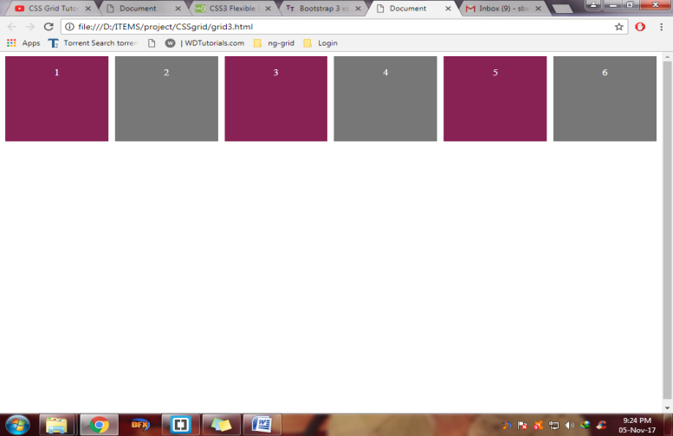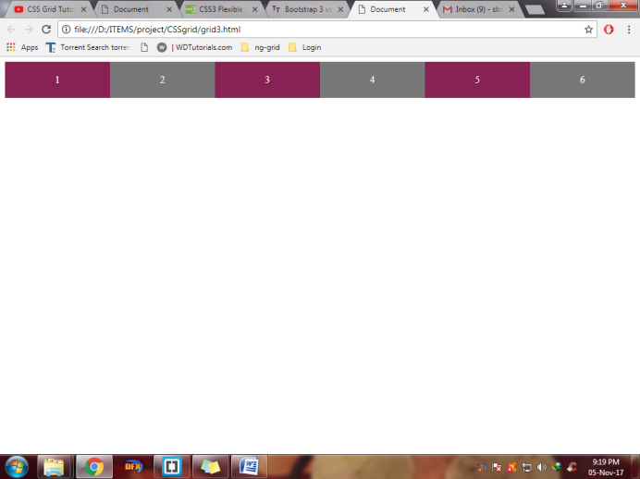 We want first div to take up 3 columns upto div3.So we write

.one

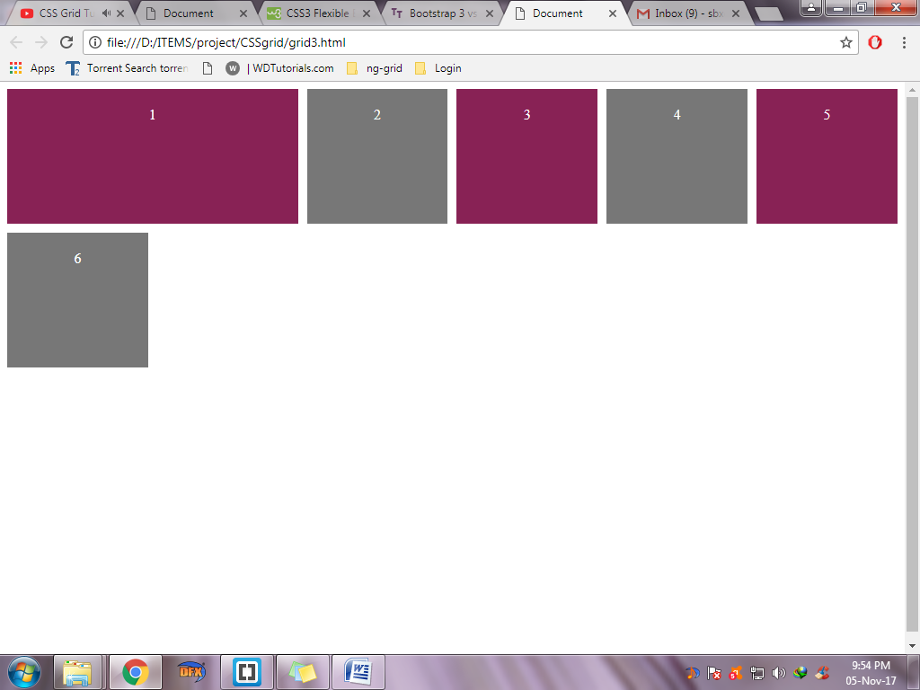 {

grid-column-start:1;

grid-column-end:3;

}

This can also be done by

grid-column: 1/3;

Notice the div has taken up the additional space and forced div 9 to next row

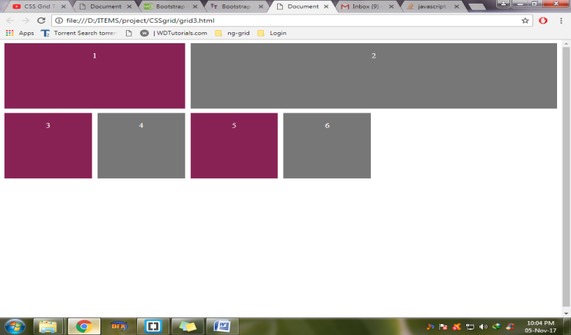Next we do the same to div2

.two

{

grid-column: 3/7;

}

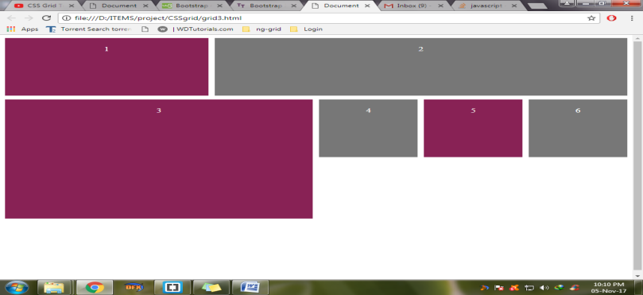Now same to div 3

Div 3 is extended from column 1 to 4 and rowise we extend from 2 to 4

.three

{

grid-column: 1/4;

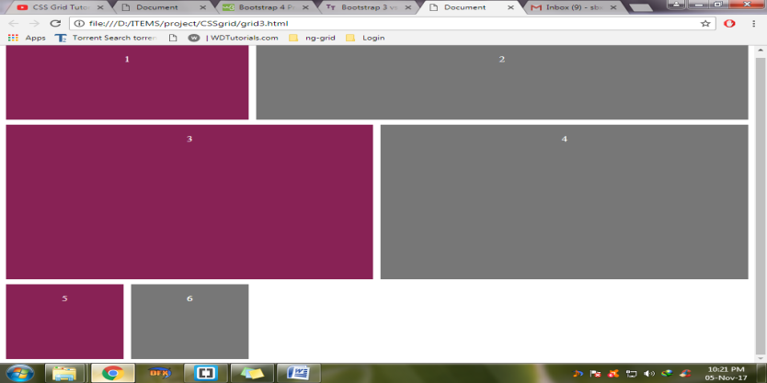 grid-row: 2/4;

}

.four

{

grid-column: 4/7;

grid-row: 2/4;

}

Now column 5 will start with a gap.So it starts from 2 to 7.

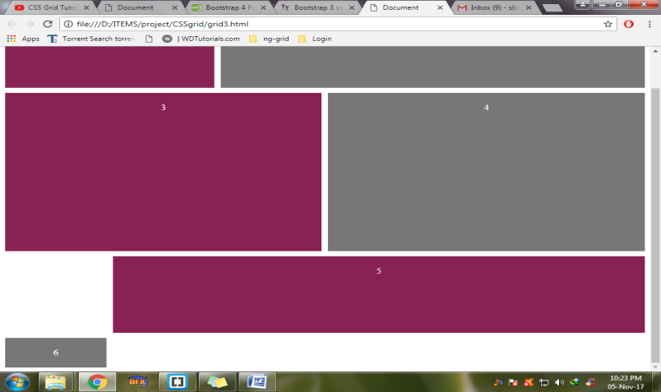

.five

{

grid-column: 2/7;

}

.six

{

grid-row: 4;

 